AVANI: All You Wanted to Know About JDMC Environment Club

Besides the usual academic Commerce and Humanities courses, the college offers a plethora of opportunities to young women to unleash their talents and explore the world.
Bhawna Pal | News18 Specials
Updated:July 7, 2018, 4:14 PM IST

Besides the usual academic Commerce and Humanities courses, the college offers a plethora of opportunities to young women to unleash their talents and explore the world.

The moment you enter the premises of the Janki Devi Memorial College located away from the hustle bustle of DU’s North campus, you cannot stop admiring it for its lush green beauty. Situated at a walkable distance from the Sir Ganga Ram Hospital Marg, this women’s college affiliated to the University of Delhi has numerous accolades to boast. From its green lawns to buzzing co-curricular societies, the college has won itself a leading name amongst off campus women colleges.
What we do
Besides the usual academic Commerce and Humanities courses, the college offers a plethora of opportunities to young women to unleash their talents and explore the world. Of the 23 societies that students can join while they journey through the three years of graduation, they are bound to learn a lot. One of the most vibrant of all the societies of the college is AVANI, the environment club. Over the years, AVANI has worked with a dedicated team of students and teachers and bagged many awards for the college.
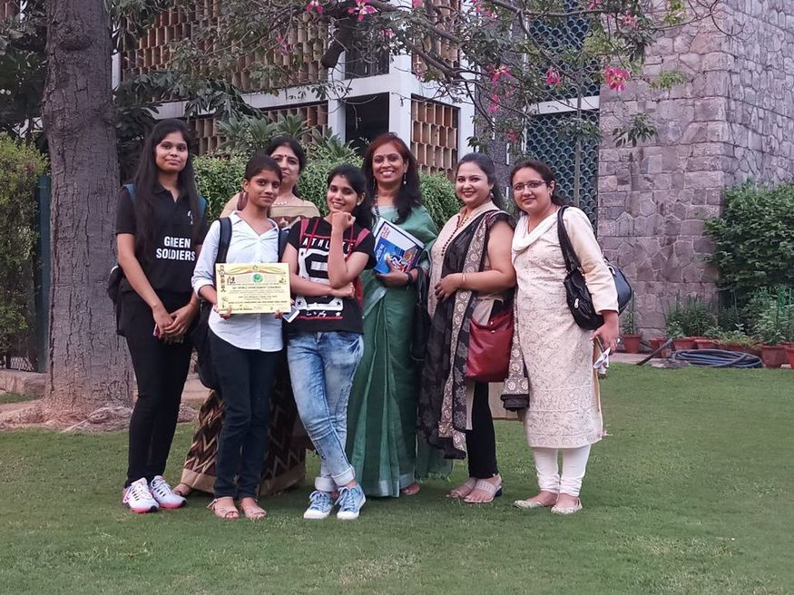
Started in 2004, AVANI is currently one of the most happening environment clubs in the University of Delhi. Under the able guidance of Ms. Vandana Madan (Associate Professor in the Department of Sociology of the college) the convenor of the club since its inception, AVANI has worked on multiple environment friendly campaigns.
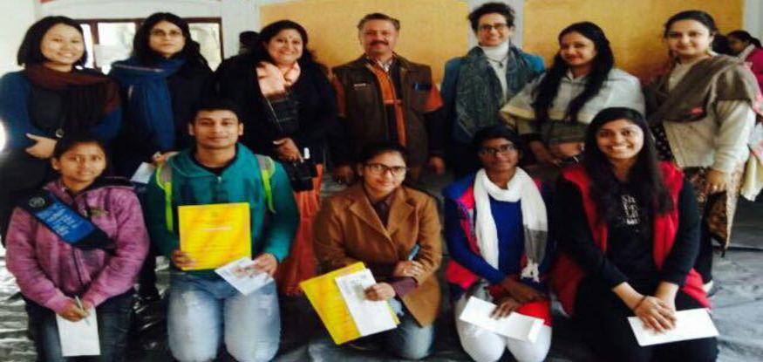
Twice a year, AVANI collects clothes and food items under its PROJECT WARMTH and donates these to Goonj, a leading NGO. The club also has collaborations with other NGOS like Chintan and Give me Trees for its e-waste management and ECO-ZONE work.
The year that was
In the previous academic session, Team AVANI worked laboriously to convert one end of its campus that had remained a dumping ground for years into an ECO-ZONE. There is a composting pit in the ECO-ZONE where the kitchen waste from the college canteen goes daily. In a few months from now, the college will have its own compost too.
The ECOZONE grows saplings and vegetables. This year we had a successful crop of spring onions, bottle gourd, brinjal and gotukoli.
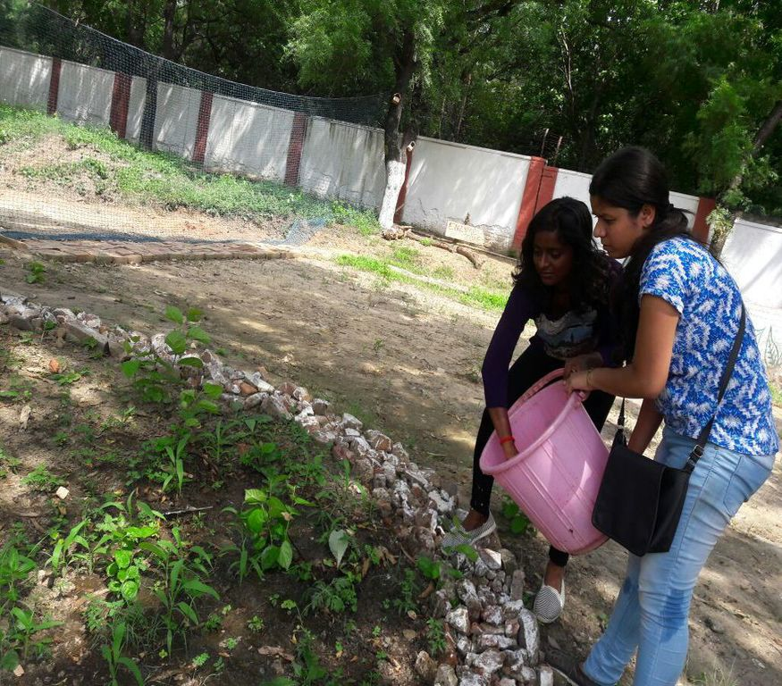
With the help of a workshop with Give me Trees, students have learnt to make bio enzymes from kitchen waste to be used in the ECOZONE. AVANI has also successfully conducted the Green Audit and Tree Census for the college. One of the only Delhi University college to do so.
AVANI and JDMC strive constantly to create a green environment and reduce our Carbon footprint. We are particularly concerned with creating a plastic free environment. Last year we campaigned to promote the use of paper bags .This year we are working even harder to reduce the use of plastic bags on our campus and in the neighborhood.
This has been done through our “AAO BAG BANAYE” campaign with the support of the college Principal Dr. Swati Pal.
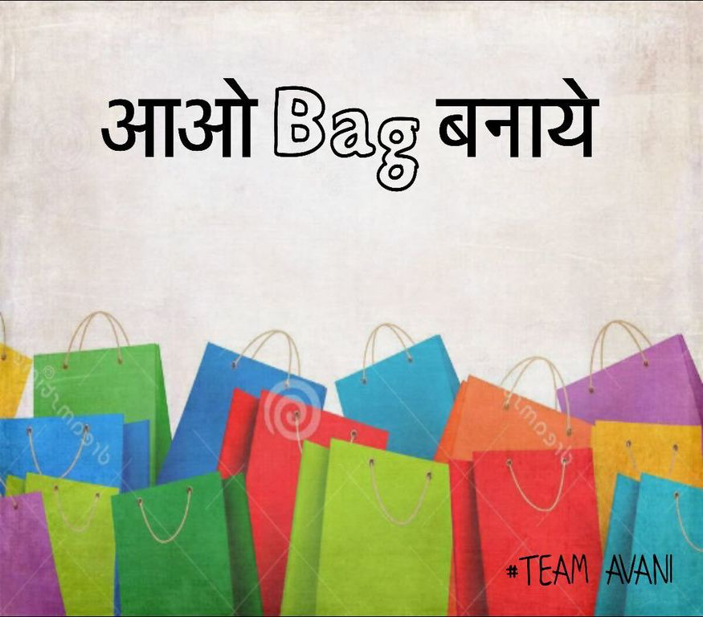
Phase 1 of the campaign was completed in April 2018 when students made and distributed bags all over the college campus and neighbouring markets and residential areas.
Phase 2 has commenced and the campaign will cover more areas.
We are also bringing non disposable cutlery to the college canteen such as eatable straws and plates and spoons.
AVANI and the garden committee of the college celebrated the World Environment Day for the first time in college on June 5, 2018. Saplings were planted by faculty members, non-teaching staff and students.
Past achievements
We are also conscious of regenerating resources and the college has three rainwater harvesting pits and solar lights as well as a functional solar grid system. The rain water harvesting pits was the initiative taken by the Garden Committee many years ago and AVANI took up the restructuring and relocation of the third rain water harvesting pit of the college, which is now the largest pit among all three. For its efforts in rainwater harvesting, in 2007, the college won 2nd position in institutional category. JDMC has also received the GREEN CAMPUS AWARD in 2017.
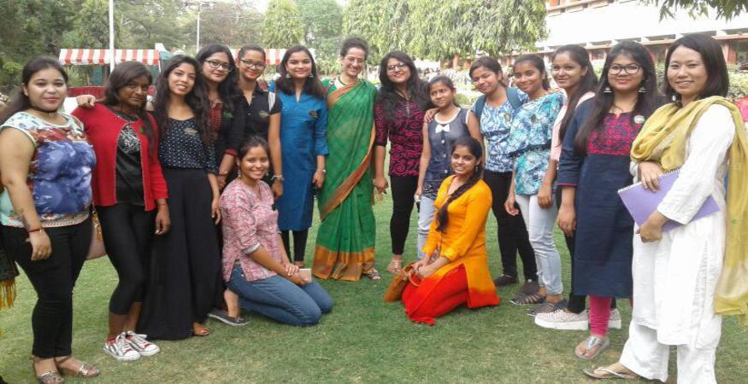
Since 2016, the club has started an annual debate competition “GREEN MATTERS” to educate people and especially the youth about the issues crippling the environment today. The competition has seen superb participation since its inception. Besides this, in the annual college festival SYMPHONY, for 14 years now, team AVANI hosts an event Create from Waste. JDMC was the first college ever to have such an event in its annual festival. Today the competition attracts youth from across Delhi-NCR and it’s heartening to see how young minds create amazing things from waste. AVANI took up the task of introducing solar lights on the campus. In collaboration with the NGO Chintan, JDMC is also one of the few Delhi University colleges to have E-waste collection on a regular basis.
Road ahead
The AVANI team from the upcoming academic session plans to begin its outreach program to spread environmental awareness among a larger community. It believes that every single step taken does make a difference. It is also looking for ways to reduce consumption of one time use plastic and the roadmap for the same is in the making. We will be taking our E-waste campaign and Aao Bag Banaye campaign to neighbouring schools as our educational outreach programme for 2018- 2019.
The members of AVANI are green soldiers and are proud of the work they have been doing for years now. So, if any of you out there feels as passionately as team AVANI does about our planet and our environment, then don’t forget to join JDMC this academic session and be prepared to carry with you a cloth bag made by you and contribute to AVANI’s motto this year of “Reduce, Refuse, Recycle”.
(Bhawna Pal is Assistant Professor, Department of Commerce, and Member of AVANI at Janki Devi Memorial College, University of Delhi)

